**Table of Contents**

**Abstract** 4

**Introduction** 5

**Software Requirements Specification - SRS** 6

**Design** 9

**Class Diagram** 9

**State Diagram** 10

**Use case Diagram** 11

**Sequence Diagram** 12

**Activity Diagram** 15

**Collaboration Diagram** 18

**ER Diagram** 18

**Component Diagram** 19

**Package Diagram** 20

**Deployment Diagram** 21

**Data Dictionary** 21

**Implementation Details** 23

**Modules** 23

**Function prototypes which implement major functionality** 23

**Testing** 24

**Screenshots** 25

**Conclusion** 31

**Limitation and Future Extensions** 32

● **Limitations** 32

● **Functionalities not implemented** 32

● **Possible future extensions** 32

**Bibliography** 33

# **Abstract**

This project involves building an attendance system which utilizes facial recognition to mark the presence, time-in, and time-out of employees. It covers areas such as facial detection, alignment, and recognition, along with the development of a web application to cater to various use cases of the system such as registration of new employees, addition of photos to the training dataset, viewing attendance reports, etc. This project intends to serve as an efficient substitute for traditional manual attendance systems. It can be used in corporate offices, schools, and organizations where security is essential.

**Purpose**

The purpose of this document is to specify software requirements of the Attendance Management System Using Face Recognition. It is intended to be a complete specification of what functionality the Attendance Management System provides.

Furthermore, this project aims to automate the traditional attendance system where the attendance is marked manually. It also enables an organization to maintain its records like in-time, out time, break time and attendance digitally. Digitalization of the system would also help in better visualization of the data using graphs to display the no. of employees present today, total work hours of each employee and their break time. Its added features serve as an efficient upgrade and replacement over the traditional attendance system.

**Scope**

Facial recognition is becoming more prominent in our society. It has made major progress in the field of security. It is a very effective tool that can help low enforcers to recognize criminals and software companies are leveraging the technology to help users access the technology. This technology can be further developed to be used in other avenues such as ATMs, accessing confidential files, or other sensitive materials.

# This project servers as a foundation for future projects based on facial detection and recognition. This project also convers web development and database management with a user-friendly UI. Using this system any corporate offices, school and organization can replace their traditional way of maintaining attendance of the employees and can also generate their availability(presence) report throughout the month.

# **Introduction**

## **Brief Introduction**

This project aims to automate the traditional attendance system where the attendance is marked manually. It also enables an organization to maintain its records like in-time, out time, break time and attendance digitally. Digitalization of the system would also help in better visualization of the data using graphs to display the no. of employees present today, total work hours of each employee and their break time. Its added features serve as an efficient upgrade and replacement over the traditional attendance system.

## **Technology/Platform/Tools used**

**Technology:**

* Django
* OpenCV
* Dlib
* Open-Source Face Recognition Library
* SQLITE Database.
* JavaScript
* Bootstrap

**Platform:**

* Windows
* Linux

**Tools:**

* Visual Studio Code / PyCharm

# **Software Requirements Specification - SRS**

We have 2 types of users of the system.

1. Employee
2. Admin

Following functionalities can be performed by the admin:

* Login
* Register new employees to the system
* Add employee photos to the training data set
* Train the model
* View attendance report of all employees. Attendance can be filtered by date or employee.

Following functionalities can be performed by the employee:

* Login
* Mark his/her time-in and time-out by scanning their face
* View attendance report of self

## **Functional Requirements**

**1.1 Manage Registration and Login**

**1.1.1 Register new employee**

Description: Admin can register new

Input: Employee Details

Output: success message displaying the user has been created.

**1.1.2 Log-In to the system**

Input: User credentials

Output: If the credentials are correct, user will be redirected to the dashboard of the system

Exception Flow: If the entered credentials are incorrect then user will be redirected to the login page again displaying an error message.

**1.2 Manage Attendance Details**

**1.2.1 Mark your attendance-in**

Input: User will scan his/her face using the external web camera.

Output: system will identify the user uniquely and will mark his/her in-time to the database. The same success message will be transmitted to the user.

**1.2.2 Mark your attendance-out**

Input: User will scan his/her face using the external web camera.

Output: system will identify the user uniquely and will mark his/her out-time to the database. The same success message will be transmitted to the user.

**1.2.3 View my attendance report**

Description: Employee may often need to see his / her attendance record throughout the month or year. Using this feature one can see his / her attendance record till the date.

Input: User selection

Output: Statistical analytics of the particular employee who is currently logged into the system will be displayed.

**1.2.4 View employee’s attendance report**

Description: This feature is for admin. Admin can monitor the availability of each employee till the date. i.e., how many employees are present today out of total employees etc. can be monitored.

Input: user selection

Output: Attendance record of each employee including how many employees are present today out of total along with the availability graph.

**1.3 Manage Employee Details**

**1.3.1 Add photo of the employee**

Description: Admin only can access this feature. Admin can add a photo of an employee during the registration process.

Input: Username of an employee

Output: Success message record has been added.

Process: System will process an image and will generate necessary system data to identify each employee uniquely.

**1.3.2 Train the system**

Input: user selection

Output: system will process all the available records of the employees and will generate necessary system data to identify each employee uniquely.

# **Design**

## **Class Diagram**

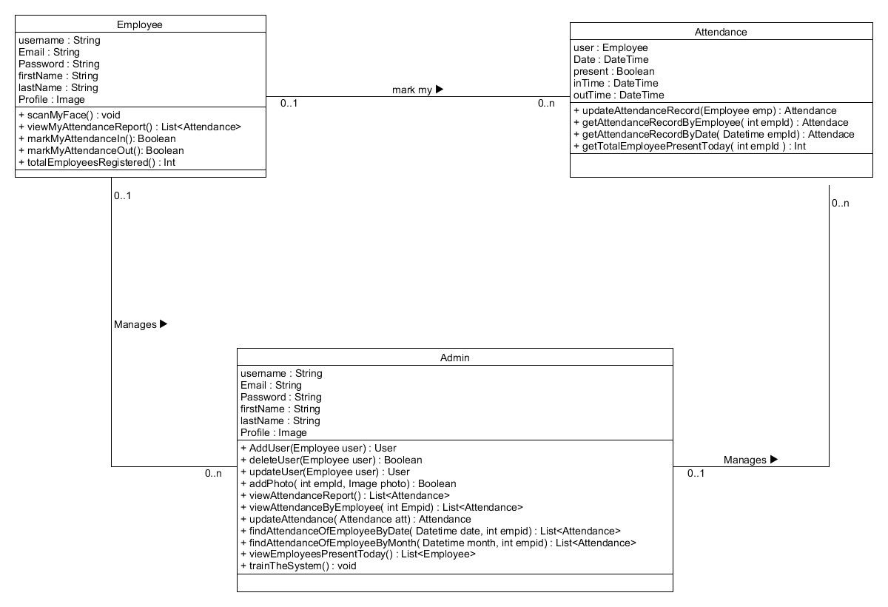

## **State Diagram**

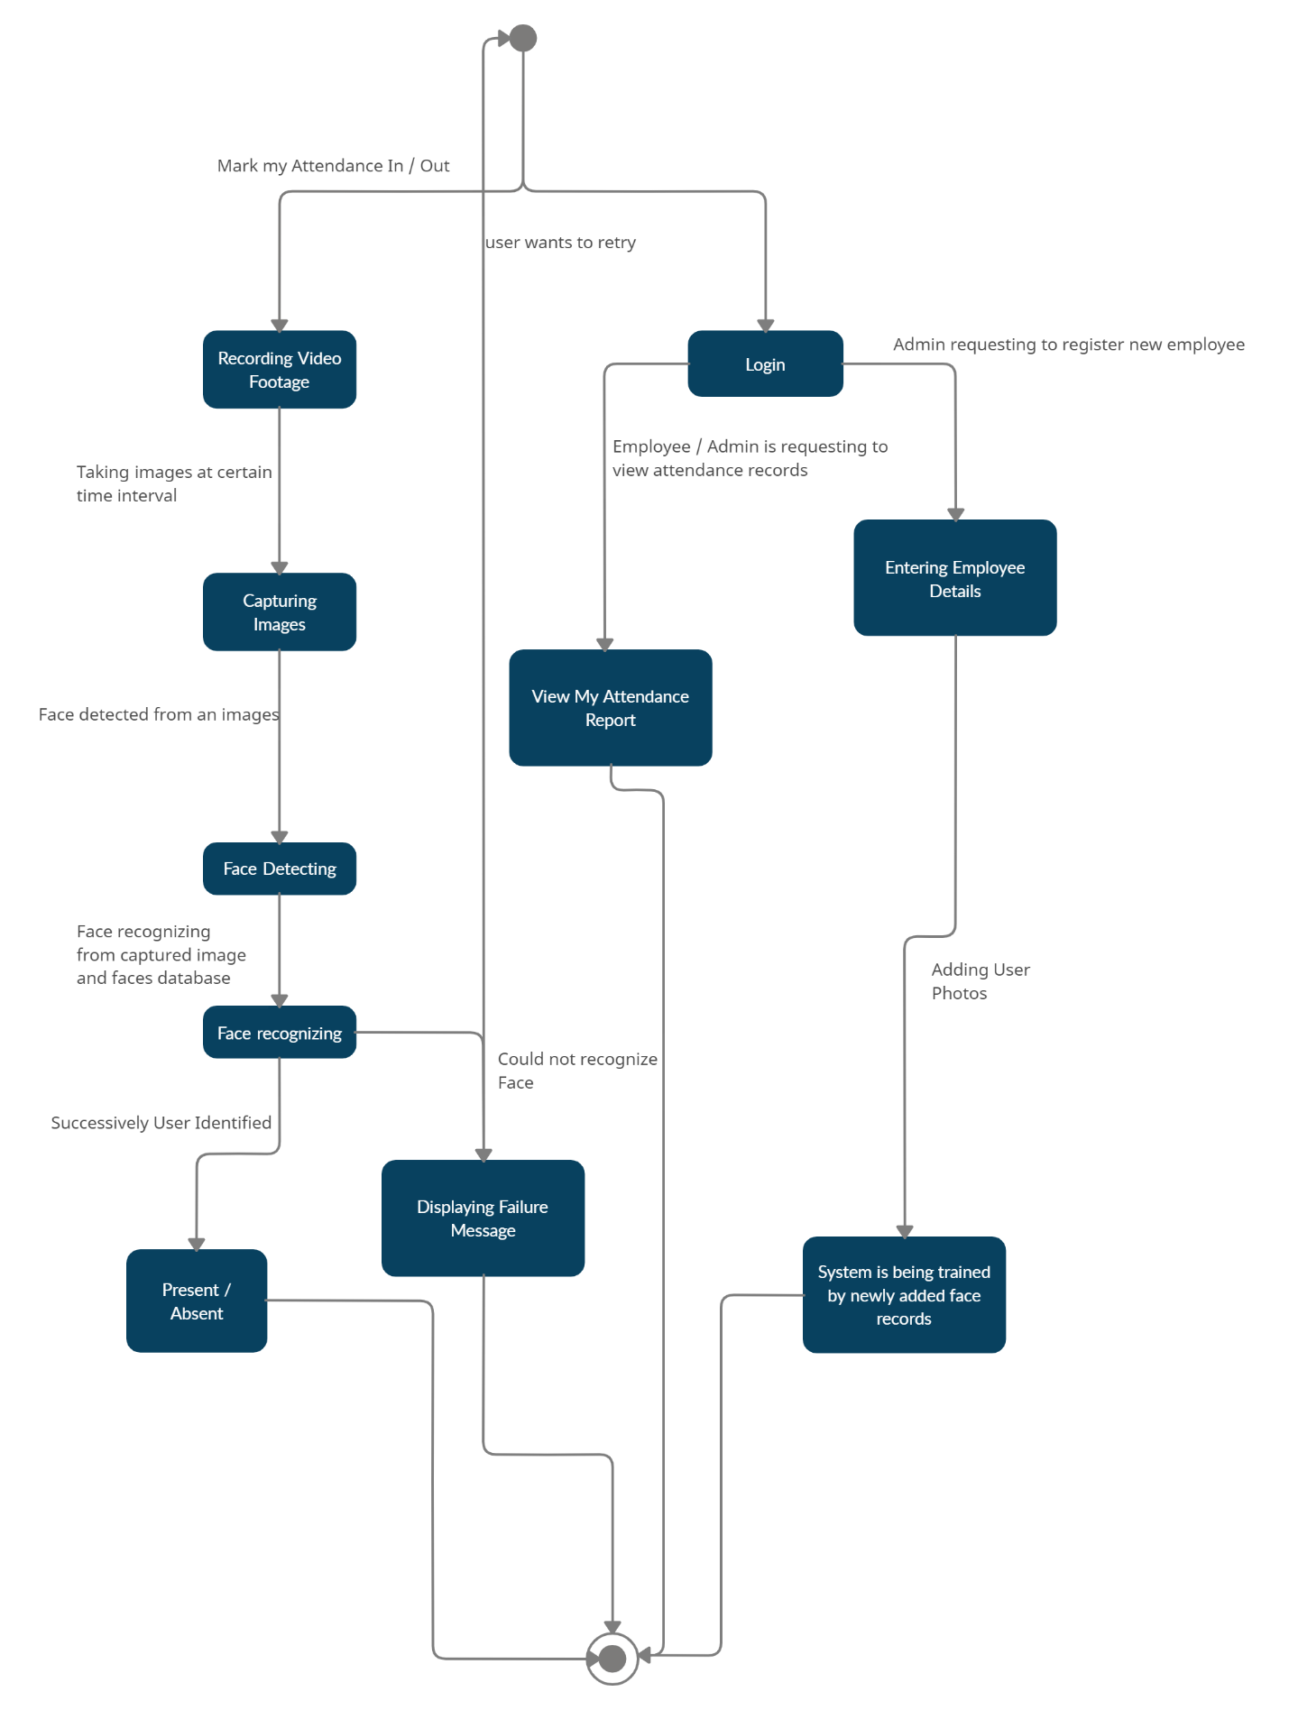

## **Use case Diagram**

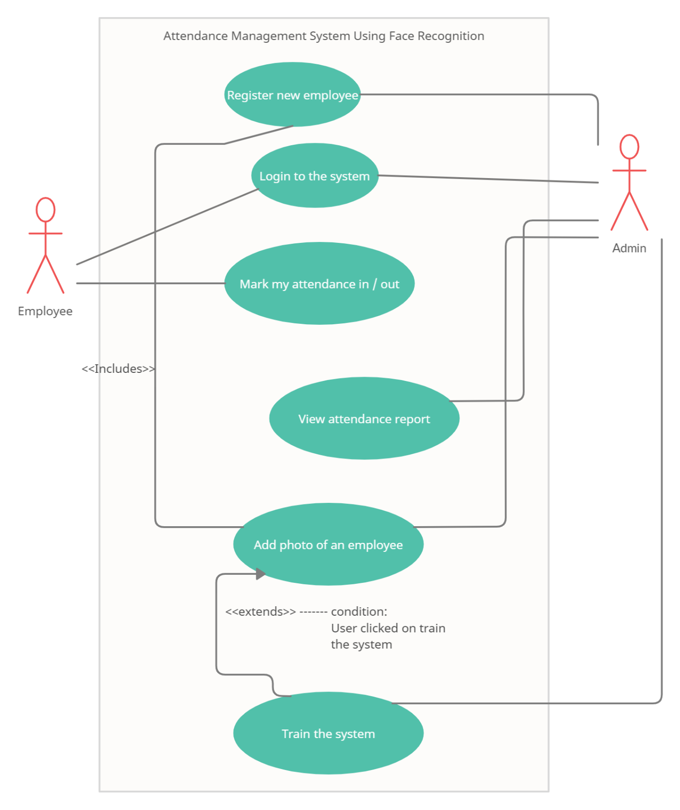

## **Sequence Diagram**

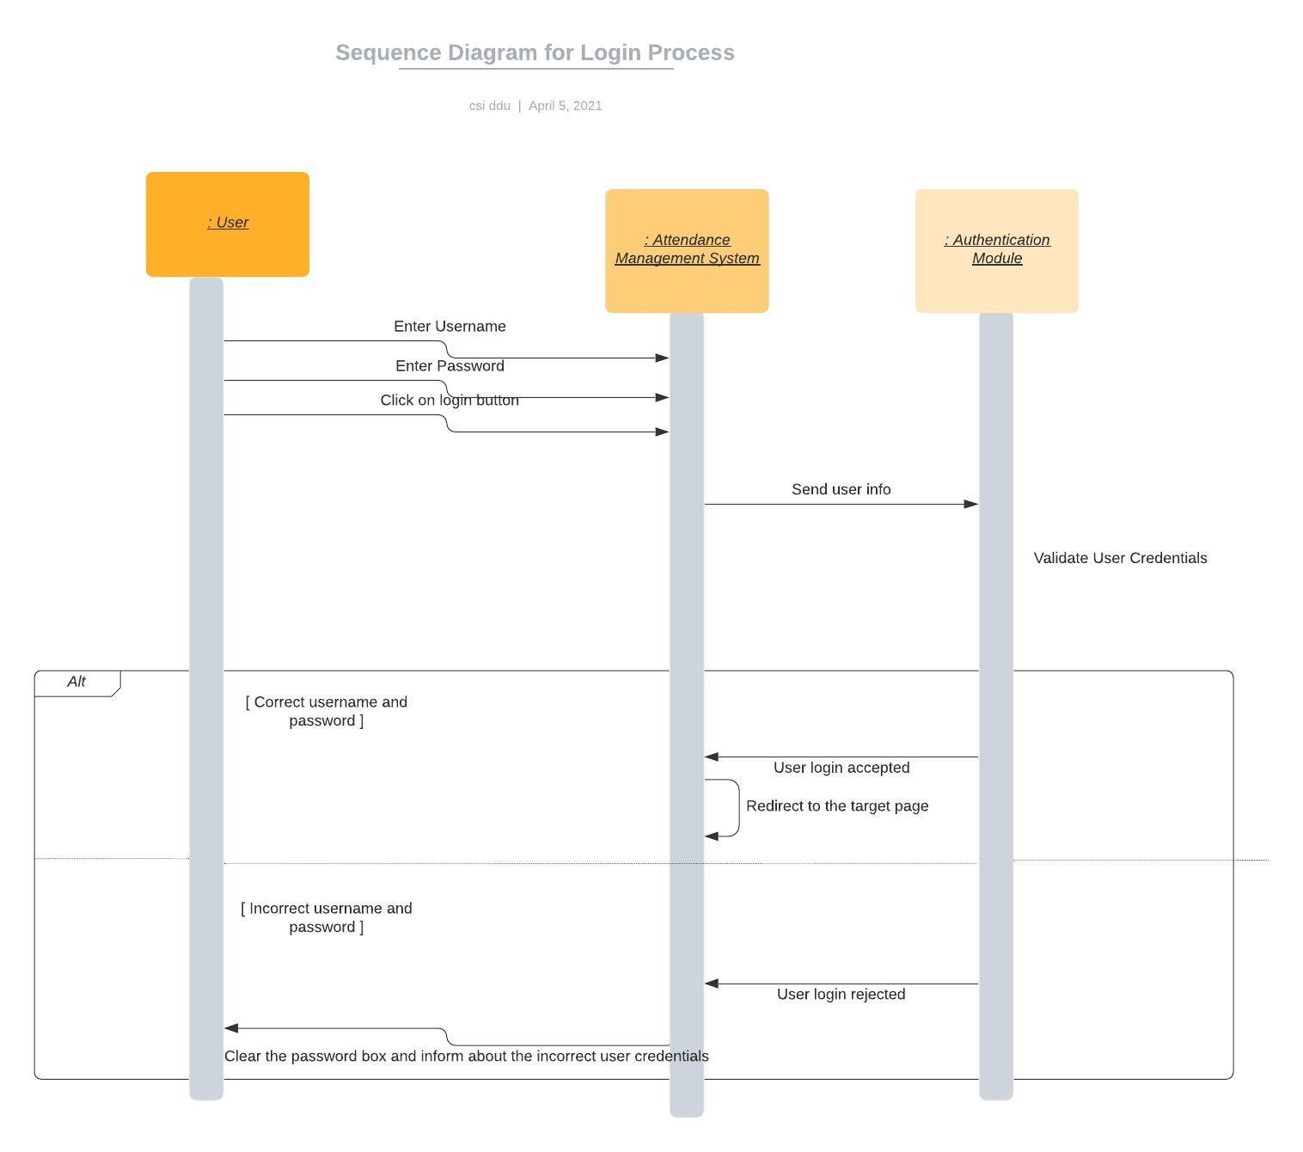

## 

## 

## **Activity Diagram**

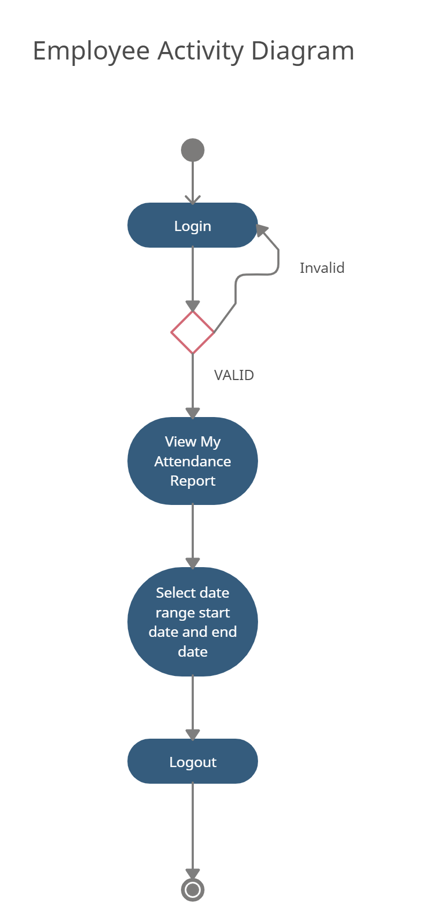

## 

## 

## **Collaboration Diagram**

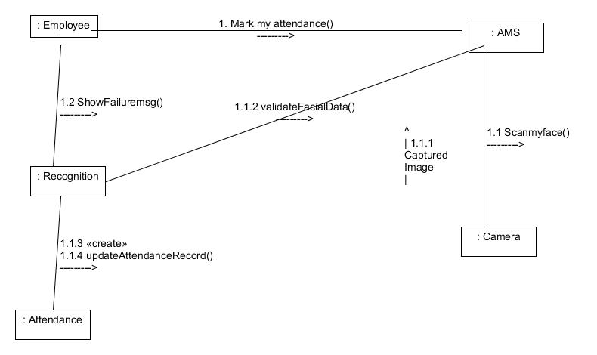

## **ER Diagram**

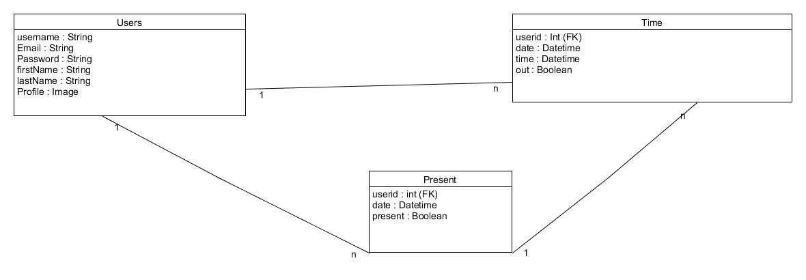

## **Component Diagram**

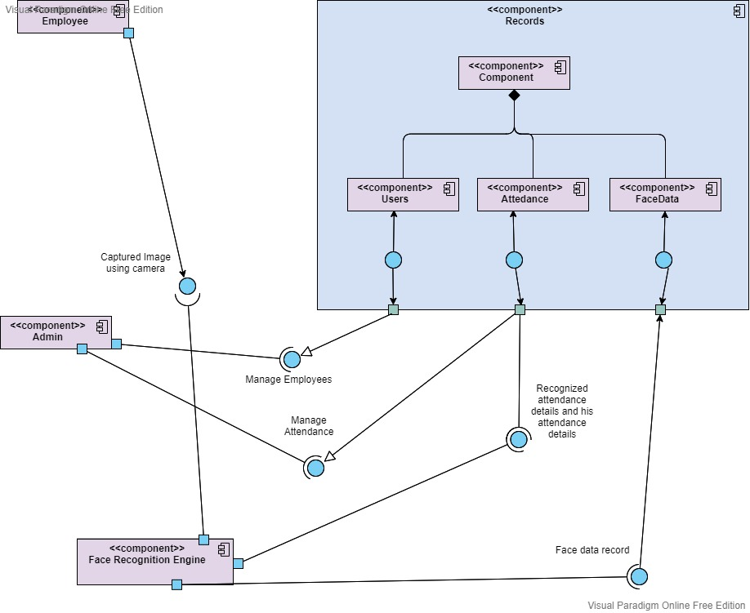

## **Package Diagram**

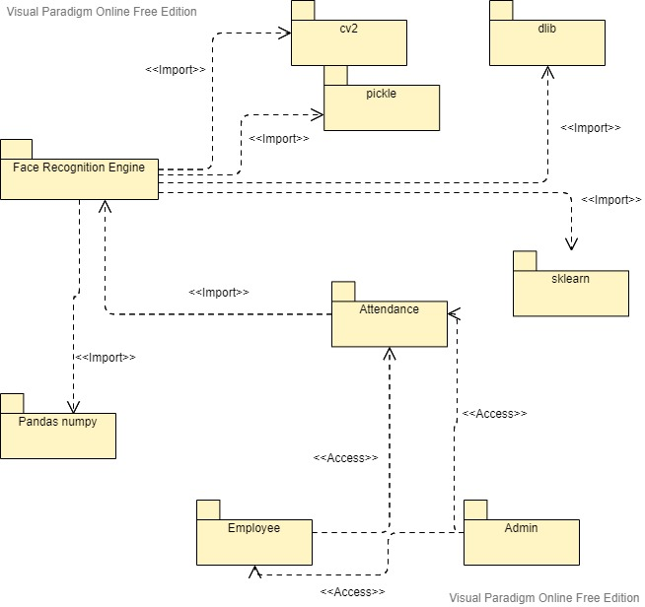

## **Deployment Diagram**

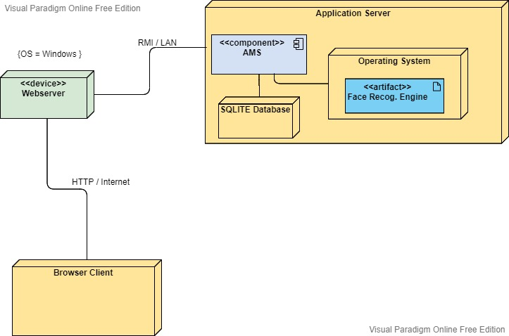

**Data Dictionary**

### **User**

|  |  |  |  |  |  |  |
| --- | --- | --- | --- | --- | --- | --- |
| **No** | **Field name** | **Data type** | **Required** | **Unique** | **PK / FK** | **Ref. Table** |
| 1 | UserId | int | true | true | PK | - |
| 2 | Email | string | true | true | - | - |
| 3 | Name | string | true | false |  | - |
| 4 | Password | string | true | false | - | - |
| 5 | CreatedAt | Datetime | true | false | - | - |
| 6 | UpdatedAt | Datetime | True | False | - | - |

### **Present**

|  |  |  |  |  |  |  |
| --- | --- | --- | --- | --- | --- | --- |
| **No** | **Field name** | **Data type** | **Required** | **Unique** | **PK / FK** | **Ref. Table** |
| 1 | PId | int | true | true | PK | - |
| 2 | Date | Datetime | True | False | - | - |
| 3 | User | User | True | False | FK | Users |
| 4 | Present | Boolean | True | False | - | - |

### 

### **Time**

|  |  |  |  |  |  |  |
| --- | --- | --- | --- | --- | --- | --- |
| **No** | **Field name** | **Data type** | **Required** | **Unique** | **PK / FK** | **Ref. Table** |
| 1 | TId | int | true | true | PK | - |
| 2 | Date | Datetime | true | True | - | - |
| 3 | User | Users | True | False | FK | Users |
| 4 | Time | Datetime | False | False | - | - |
| 5 | Out | Boolean | True | False | - | - |

### 

# **Implementation Details**

## **Modules**

The features of the system are mainly divided into 3 modules.

**Registration and Login Module**

This module mainly deals with the functionalities related to the registration of any new employee to the organization, Log into the system and managing employee’s profile details. Using features provided by this module admin can register new employee to the system and admin / employee both can log into the system using their credentials.

**Manage Attendance Details**

This module mainly deals with the features related to the employee’s attendance. Using this employee can mark their presence, time-in and time-out in the system. Admin can see the availability report of each employee, employee can see his/her attendance report along with some possible filters such as filter by employee and filter by date.

**Manage Employee Details**

This module mainly deals with the features related to the employee’s profile. Using this admin can add a photo of the newly registered employee during registration. Admin can also command the system explicitly to train the model and system will make necessary calculation and will generate some data which will be used internally to identify each employee uniquely.

## **Function prototypes which implement major functionality**

* List<Attendance> viewMyAttendanceReport(int empId);
* Int totalEmployeesRegistered();
* List<Attendance> getAttendanceRecordByEmployee(int empid);
* Boolean updateAttendanceRecord(int empid, Attendance update);
* Boolean registerEmployee(Employee new_employee);
* Boolean addPhoto( int empId, string photo);

# **Testing**

Unit testing of each module was done after successfully completing the module. Each module was tested individually before integrating them with the whole system.

After integrating each module with the system, integration testing was done in order to check if modules are working properly together.

After completing all integrations, black-box testing of the whole system was carried out to ensure the system works in a correct manner.

**Black box testing of Major functions of the system**

### **Log in to the system.**

**Case 1:** Invalid Username or password entered by the user.

**Output:** Error message on the screen saying “Invalid credentials”

**Case 2:** Valid credentials.

**Output:** The user is redirected to the Dashboard page.

### **Update Profile**

**Case 1:** username already exists.

**Output:** Error message on the screen saying “Username already exists”

**Case 2:** Some of required fields missing in input.

**Output:** Model validation errors will be displayed to the user.

**Case 3:** All input data are valid.

**Output:** Profile updated successfully.

### **View Attendance.**

**Case 1:** User is not logged in.

**Output:** Redirected to the login page with error message “Please login!”.

**Case 2:** If a user exists and has the attendance records.

**Output:** All the chat history will be displayed

**Case 4:** Provided username does not exists in the system.

**Output:** 404 Error.

# **Screenshots**

**Login**

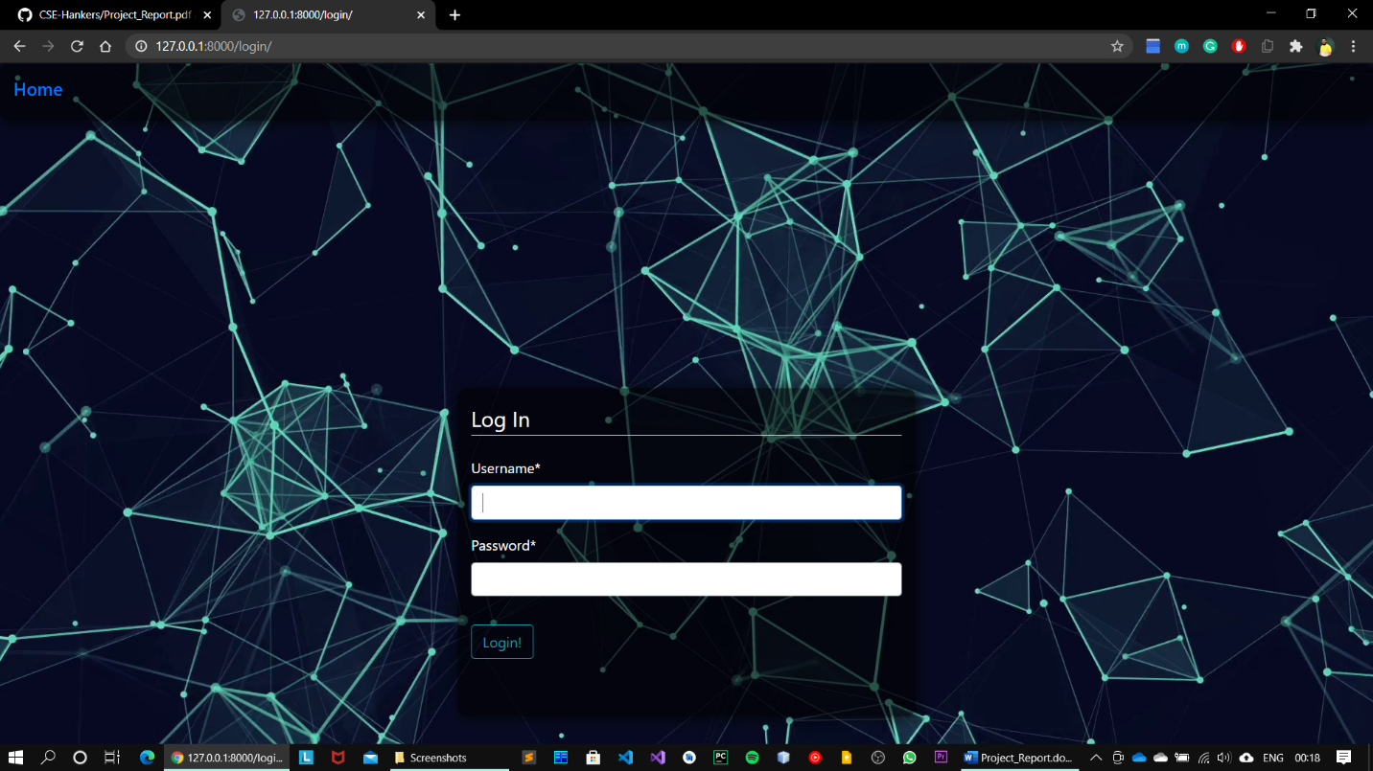

**Mark my attendance In / Out**

# 

**Scanning Face**

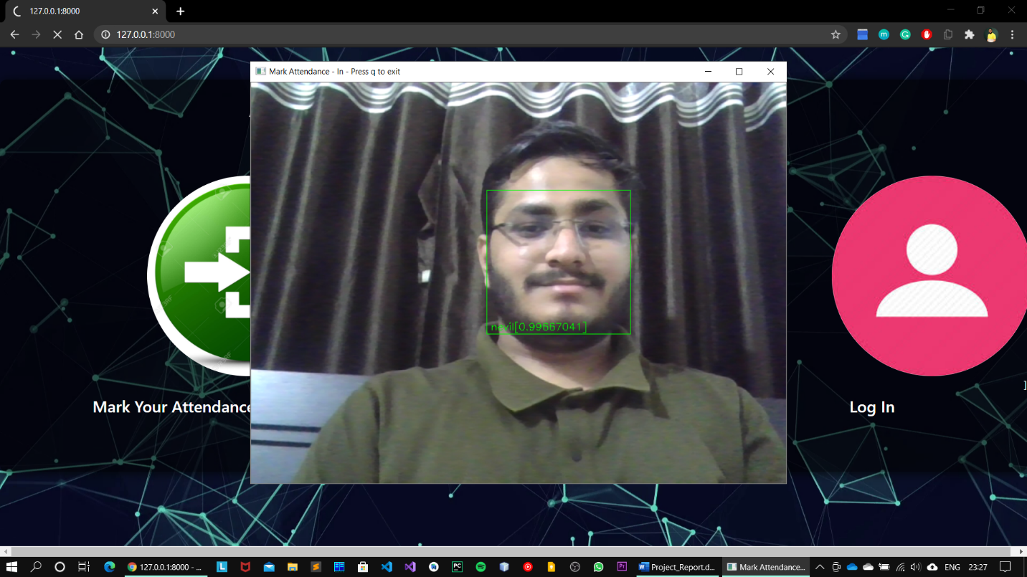

**View Attendance Records by Admin**

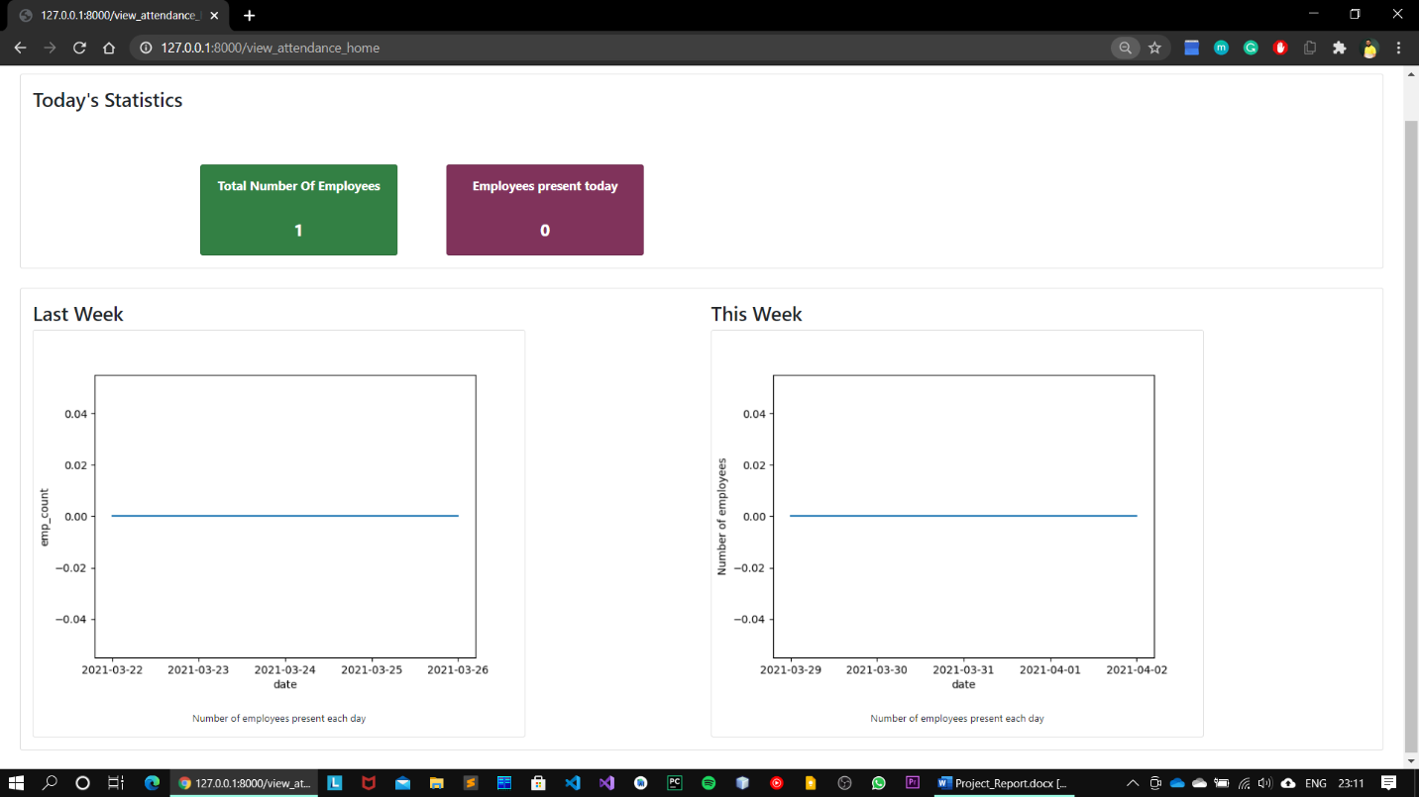

**Trained Dataset Output**

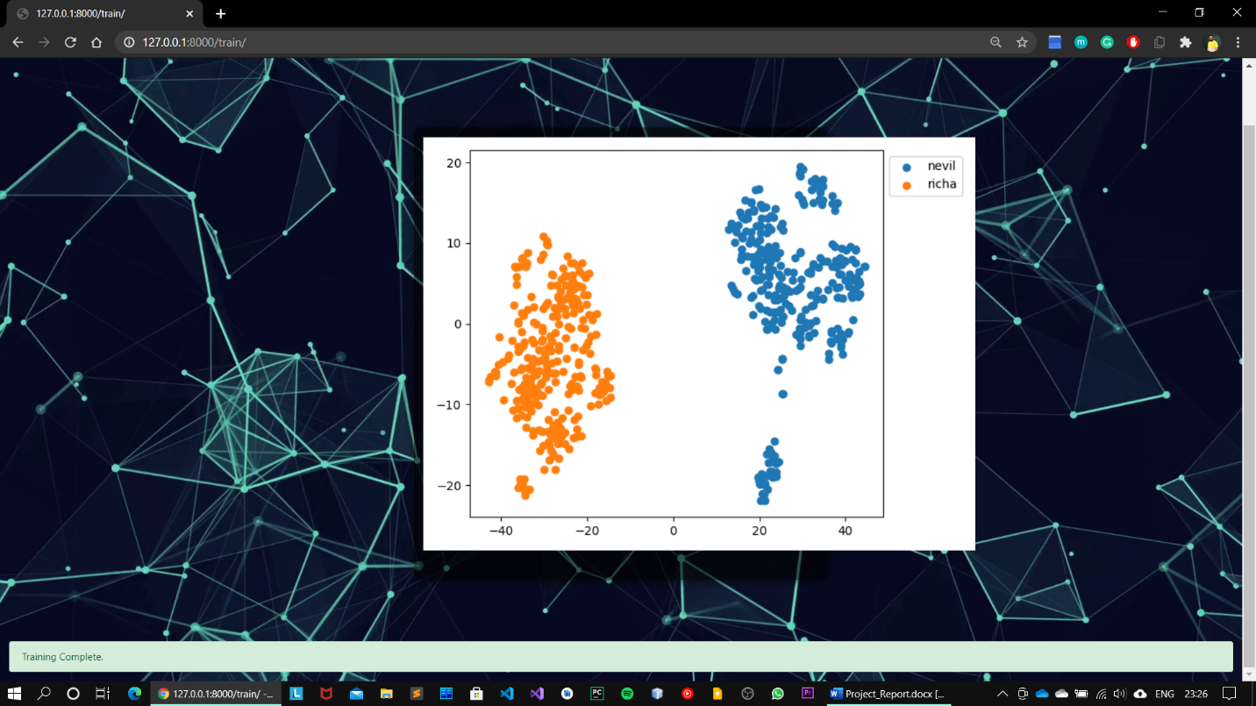

**Add Photos**

# 

**Employee Dashboard**

# 

**View My Attendance By Employee**

# 

**Admin can filter attendance by employee / by date**

# 

# 

**Training Model (Approx. 300 Images / employee)**

# 

# **Conclusion**

**Functionalities implemented successfully:**

* Registration
* Login / Logout
* Manage User Profile
* Update user profile
* View My Attendance
* View Attendance by Date
* View Attendance by Employee
* Manage Attendance
* Mark my attendance In
* Mark my attendance Out
* Add photos
* Add new employee
* Train the system
* View Attendance record by date
* View no. of employee present today
* View Total number of employees

# **Limitation and Future Extensions**

## **Limitations**

* Attendance can be marked if the picture of an employee is shown
* 300 images of each employee are taken for better accuracy. 300 Images per employee in a larger organization would consume a massive volume to store the images.
* The training time for our classifier takes about 20 seconds for each person. Hence for a large number of employees, it would take a very long time to train. Though training the classifier isn’t something that needs to be frequently done, but it would be better if a classifier taking lesser time while maintaining the accuracy can be built.
* The current model is 99.38% Accurate

## **Functionalities not implemented**

* Alert System
* Forgot Password
* Email Notifications

## **Possible future extensions**

* A feature which can give intruder alert can be included in the system. Furthermore, the images of unknown people can be saved in an efficient manner and displayed in the system for better security.
* The number of training images can be reduced so that less storage is required. This can be done by removing duplicate images of the same person, or images with similar embeddings.
* The training time can be reduced by retraining the classifier only for the newly added images.
* A feature can be added where an employee is automatically sent a warning if his attendance or working hours are below the threshold.
* Wrongly classified images can be added to the training dataset with the correct label so as to increase the accuracy of the recognition model.

# **Bibliography**

[**The Web framework for perfectionists with deadlines | Django (djangoproject.com)**](https://www.djangoproject.com/)

[**https://medium.com/**](https://medium.com/)

[**http://dlib.net/**](http://dlib.net/)

[**https://opencv.org/**](https://opencv.org/)

* CSS & Bootstrap:

[**https://getbootstrap.com/**](https://getbootstrap.com/)

* For debugging:

[**https://stackoverflow.com/**](https://stackoverflow.com/)

THANK YOU